Module : 9 – Reactjs,Components , states ,props

1] Create Hello World React program show below.
Index.js
Import React from 'react';
import ReactDOM from 'react-dom';
import'./App.css';

functionApp() {
return (
<div className ="App">
<h1>react app</h1>
<imgsrc="https://upload.wikimedia.org/wikipedia/commons/a/a7/React-icon.svg"alt="React Logo" className="logo"/>
<h1>Hello World</h1>
</div>
);
}

ReactDOM.render(<App/>, document.getElementById('root'));
root.render(
<React.StrictMode>
<App/>
</React.StrictMode>
);

css
body {
margin: 0;
padding: 0;
display: flex;
justify-content: center;
align-items: center;
height: 100vh;
background-color: black;
}

.App {
text-align: center;
color: cyan;
}

.logo {
width: 100px;
margin-bottom: 20px;
}

Output:
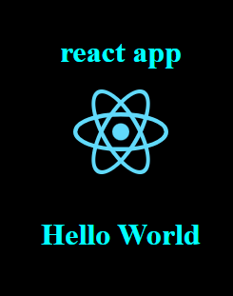

2]Create counter app program shown below.

Step 1: Set Up Your ReacStep 1: Set Up Your React App

npx create-react-app counter-app
cd counter-app
npm start

Step 2: Create the Counter Component

importReact, { useState } from'react';

constCounter= () => {
const [count, setCount] =useState(0);

return (
<divstyle={{ textAlign:'center', marginTop:'50px' }}>
<h1>Counter App</h1>
<h2>{count}</h2>
<buttononClick={() =>setCount(count + 1)}style={{ marginRight:'10px', padding:'10px', backgroundColor:'green', color:'white' }}>Increment</button>
<buttononClick={() =>setCount(count - 1)}style={{ padding:'10px', backgroundColor:'red', color:'white' }}>Decrement</button>
</div>
);
};

exportdefaultCounter;

Step 3: Use the Counter Component

importCounterfrom"./Counter";

functionApp() {
return (
<div>
<Counter/>
</div>
);
}

exportdefaultApp;

Step 4: Run Your App

npm start

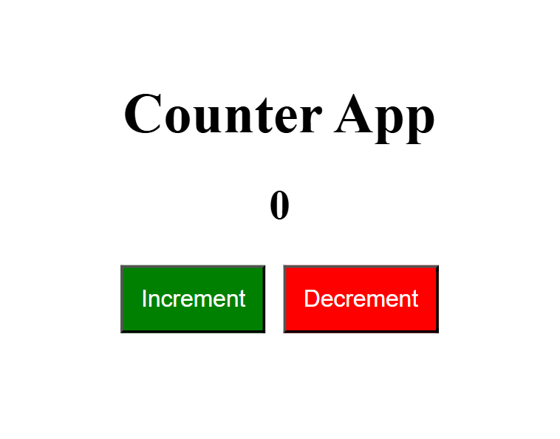

3] Create Login Lout React program as below

Create the Layout Components

Navigation Component

importReactfrom'react';

constNavigation= ({ isLoggedIn, handleLogin }) => {
return (
<navstyle={{ padding:'10px', backgroundColor:'orange' , width:'200px', height:'50px',}}>
<h2>Navigation</h2>
<buttononClick={handleLogin}style={{ padding:'10px', margin:'10px',marginLeft:'150px', markerEnd:'200px' }}>

{isLoggedIn ?'Logout' :'Login'}
</button
</nav>
);
};

exportdefaultNavigation;

Public Views Component
Create a file named PublicViews.js:
importReactfrom'react';

constPublicViews= () => {
return (
<div>
<h2>Public Views</h2>
</div>
); };
exportdefaultPublicViews;

Private Views Component
Create a file named PrivateViews.js:
importReactfrom'react';

constPrivateViews= () => {
return (
<div>
<h2>Private Views</h2>
</div>
);
};

exportdefaultPrivateViews;

Footer Component
Create a file named Footer.js:
importReactfrom'react';

constFooter= () => {
return (
<footerstyle={{ padding:'10px', backgroundColor:'green', marginTop:'20px', width:'200px' }}>
<p>Footer</p>

</footer>

);
};

exportdefaultFooter;

Create the Main App Component

importReact, { useState } from'react';
importNavigationfrom'./Navigation';
importPublicViewsfrom'./PublicViews';
importPrivateViewsfrom'./PrivateViews';
importFooterfrom'./Footer';

functionApp() {
const [isLoggedIn, setIsLoggedIn] =useState(false);

consthandleLogin= () => {
setIsLoggedIn(!isLoggedIn);
};

return (
<divclassName="App">
<NavigationisLoggedIn={isLoggedIn}handleLogin={handleLogin}/>
{isLoggedIn ?<PrivateViews/> : <PublicViews/>}
<Footer/>

</div>
);
}

exportdefaultApp;

